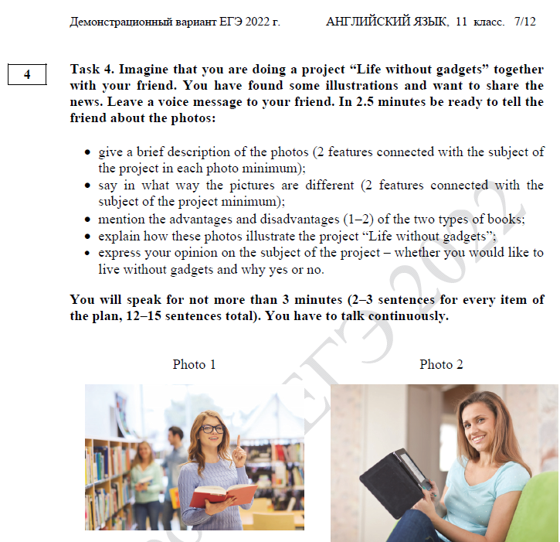
Hi there! Have you received the pictures I’ve sent you by e-mail? I suppose they are perfect for our project “Life without gadgets”.
- In pic 1 there is my mum in her student years. It’s obvious 1) there WERE NO gadgets at that time. However, judging by the number of people in the library, 2) reading was quite popular in those days. As for pic 2, there is my cousin Mary 1) who can’t imagine her life WITHOUT gadgets as she 2) belongs to a digital-savvy generation.
- No doubt the photos are different. Pic 1 illustrates a gadget-free environment where readers had to use traditional paper books. Concerning pic 2, my cousin can read a book at home as she has got an e-book.
- As for pros and cons, I believe the only advantage of a paper book is that you can leave some remarks while reading. Its disadvantage is a necessity to go to the library every time you need it. As for the advantage of e-readers, it’s their ability to store as many books as you need. However, they can crash suddenly when you forget to charge them in time.
- I’m sure these photos illustrate our project perfectly. On the one hand, pic.1 proves that life without gadgets can be quite full and active. My mum thinks so. On the other hand, pic.2 shows that life WITHOUT gadgets is next to impossible for generation Z.
- As I belong to a younger generation, I would like to live in a technological society and use modern gadgets as they make our life much easier and more comfortable.

Please let me know whether you agree on my choice of photos.

